

**KINDERGARTEN REGISTRATION**

**GREENTREE SCHOOL**

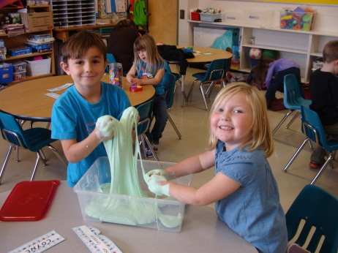

**Funded Full Day Program**

***with an option for part-time programming***

**ALL STUDENTS WELCOME!**

***Children must be 5 years old by February 28, 2017.***

***Child’s birth certificate required to registration***

***Kindergarten students benefit from:***

* *A safe, caring school environment*
* *Focus on hands-on, powerful learning*
* *Well-developed balanced literacy and numeracy programs*
* *Daily Physical Education and fine arts integration*
* *Virtues education, social and emotional skill development*
* *Strong home-school communication*
* *Cross-curricular and cross-grade activities*
* *Participation in school/community events*
* *Community field trips*
* *Active School Council and parental involvement*
* *Kindergarten Orientation in June*
* *Before and after school care available Call 403-823-1365*
* *Phone 403-823-5244 or visit our office between 8:00 – 4:00pm*
* *Registration now open*
* *Tours welcome*